# Bansilal Ramnath Agarwal Charitable Trust’s

Vishwakarma Institute of Technology, Pune -37

*(An autonomous Institute of Savitribai Phule Pune University)*



**Department of Artificial intelligence and Data Science**

| **Division** | A |
| --- | --- |
| **Batch** | 3 |
| **Roll no** | 68 |
| **PRN no** | 12320041 |
| **Name** | Heramb Sachin Bhoodhar |
| **Subject** | Web Technology |

**Assignment 3**

**Problem Statement :**

Create a dynamic blogging website that retrieves blog data from a local JSON file and displays it on the website using HTML, CSS, Bootstrap, and JSON.

**DATA :**

**data.json**

{

"blogs": [

{

"category": "Technology",

"posts": [

{

"id": 0,

"title": "The Future of Artificial Intelligence",

"img": "./images/image7.jpg",

"author": "John Smith",

"date": "2024-02-15",

"description": "Exploring the latest advancements and future prospects of artificial intelligence.",

"about_author": "John Smith is a renowned AI researcher with a passion for exploring the frontiers of technology.",

"content": "Lorem ipsum dolor sit amet, consectetur adipiscing elit. Vestibulum nec justo eu ante ultricies vestibulum. Mauris eget fermentum velit, at dapibus justo. Sed et hendrerit nisi. Nullam fringilla hendrerit neque at congue. Vestibulum id malesuada neque, eget consequat ex. Nullam quis ligula at velit blandit rhoncus. Proin ut nunc bibendum, convallis lectus eget, accumsan justo. Nam nec ullamcorper odio. Ut hendrerit sapien vel odio ultricies, nec facilisis magna pharetra. Suspendisse eu mauris sed odio fermentum sollicitudin. Duis sollicitudin mi id tortor ullamcorper, nec dictum risus varius. Nullam nec ex tellus. Suspendisse sollicitudin ultricies neque eu scelerisque. Curabitur a arcu consequat, placerat ligula id, finibus risus. Quisque vel sodales velit."

},

{

"id": 1,

"title": "The Rise of Blockchain Technology",

"img": "./images/image8.jpg",

"author": "Sarah Johnson",

"date": "2024-03-20",

"description": "Exploring the transformative potential of blockchain technology across industries.",

"about_author": "Sarah Johnson is a blockchain enthusiast and technology evangelist with a keen interest in decentralized systems.",

"content": "Lorem ipsum dolor sit amet, consectetur adipiscing elit. Praesent non tristique nulla. Vestibulum mattis justo ac lorem faucibus, non condimentum lectus volutpat. Nulla facilisi. Phasellus ac scelerisque purus. Duis posuere mauris libero, eget convallis est fermentum sed. Nulla venenatis auctor metus vel sagittis. Proin eget nulla dui. Pellentesque at libero pharetra, pharetra nunc vitae, aliquam elit. Integer ac est aliquet, consequat ligula sed, efficitur nisi. Vestibulum auctor malesuada nulla, vel fringilla nulla suscipit sit amet. Sed eleifend, nulla eu vestibulum fermentum, eros nunc tristique odio, non ultricies enim lacus eu lorem."

},

{

"id": 2,

"title": "The Evolution of Cloud Computing",

"img": "./images/image9.jpg",

"author": "Daniel Miller",

"date": "2024-04-05",

"description": "Tracing the history and future trends of cloud computing in the digital era.",

"about_author": "Daniel Miller is a cloud architect and technology strategist specializing in scalable and resilient cloud solutions.",

"content": "Lorem ipsum dolor sit amet, consectetur adipiscing elit. Sed efficitur bibendum tortor, non euismod leo efficitur vel. Curabitur vel libero fringilla, rhoncus orci sed, aliquet enim. Vivamus vitae justo eget felis interdum ultricies sed in enim. Integer nec tincidunt mauris, ac congue neque. Nulla facilisi. Vivamus sed eros mi. Proin et purus at nunc hendrerit rutrum. Vestibulum eget arcu nec lorem suscipit mattis. Duis non interdum libero. Nulla vitae feugiat odio. Integer vel ante vel nisl maximus dapibus. In hac habitasse platea dictumst. Duis gravida magna in orci sodales, eu ultrices odio volutpat."

}

]

},

{

"category": "Science",

"posts": [

{

"id": 0,

"title": "The Mysteries of the Universe",

"img": "./images/image10.jpg",

"author": "Emily Johnson",

"date": "2024-01-20",

"description": "Exploring the wonders of astrophysics and cosmology.",

"about_author": "Emily Johnson is an astrophysicist with a passion for unraveling the mysteries of the cosmos.",

"content": "Lorem ipsum dolor sit amet, consectetur adipiscing elit. Nullam interdum, magna et eleifend mattis, mauris erat facilisis risus, eu finibus magna lectus at turpis. Fusce id ipsum nec sapien fermentum eleifend a quis lacus. Ut nec elit sit amet odio scelerisque lacinia. Fusce sit amet metus metus. Morbi a quam ut erat maximus egestas. Proin fermentum blandit sagittis. Pellentesque quis tellus eleifend, lacinia tortor ac, faucibus quam. Pellentesque habitant morbi tristique senectus et netus et malesuada fames ac turpis egestas. Fusce maximus hendrerit orci. Sed nec libero massa. Nam sit amet arcu vitae libero scelerisque rhoncus."

},

{

"id": 1,

"title": "Unlocking the Secrets of Genetics",

"author": "Olivia Anderson",

"img": "./images/image11.jpg",

"date": "2024-03-25",

"description": "Diving deep into the field of genetics to understand inheritance, variation, and molecular biology.",

"about_author": "Olivia Anderson is a geneticist and researcher passionate about unraveling the mysteries of the human genome.",

"content": "Lorem ipsum dolor sit amet, consectetur adipiscing elit. Integer suscipit enim sed consectetur ultricies. Nullam dapibus hendrerit turpis, sit amet congue velit feugiat ut. Quisque vitae rhoncus dolor. Sed malesuada eu justo vel convallis. Proin non enim non ligula finibus condimentum non at urna. Donec nec nulla at enim ultrices condimentum. Vestibulum ante ipsum primis in faucibus orci luctus et ultrices posuere cubilia Curae; Nulla id risus massa. Vestibulum varius leo id odio eleifend facilisis. Donec id efficitur velit, eget laoreet mauris. Nullam sed interdum metus, ac feugiat magna."

},

{

"id": 2,

"title": "The Marvels of Marine Biology",

"img": "./images/image12.jpg",

"author": "Lucas Roberts",

"date": "2024-04-10",

"description": "Exploring the diverse ecosystems and fascinating creatures inhabiting the world's oceans.",

"about_author": "Lucas Roberts is a marine biologist dedicated to conservation efforts and marine biodiversity research.",

"content": "Lorem ipsum dolor sit amet, consectetur adipiscing elit. Vestibulum id ipsum at velit feugiat pretium. In semper nec nisi sit amet elementum. Cras eget libero id ipsum iaculis posuere ac eget erat. Duis gravida bibendum felis, vel scelerisque quam fermentum non. Aliquam erat volutpat. Integer id semper orci. Sed at ultrices quam. Curabitur in enim at turpis dignissim tincidunt. Vestibulum fermentum nibh non est tempus, eget ultricies urna commodo. Cras non turpis vel tellus malesuada placerat."

}

]

},

{

"category": "Travel",

"posts": [

{

"id": 0,

"title": "The Ultimate Adventure: Backpacking Across Southeast Asia",

"img": "./images/image1.jpg",

"author": "Michael Brown",

"date": "2024-03-05",

"description": "Embarking on a life-changing journey through the diverse landscapes and cultures of Southeast Asia.",

"about_author": "Michael Brown is an avid traveler and adventure enthusiast who has explored over 50 countries.",

"content": "Lorem ipsum dolor sit amet, consectetur adipiscing elit. Quisque pellentesque erat ac feugiat efficitur. Suspendisse eget justo eget sapien tempus consectetur eu ut mi. Sed at luctus libero. Sed vehicula, lacus eget vehicula congue, felis ex bibendum risus, at feugiat orci elit nec turpis. In hac habitasse platea dictumst. Curabitur nec turpis sit amet risus efficitur malesuada. Pellentesque habitant morbi tristique senectus et netus et malesuada fames ac turpis egestas. Phasellus consectetur purus quam, nec egestas velit laoreet nec. Nullam dictum vehicula libero, sit amet ultricies eros euismod id. Integer faucibus ac justo at malesuada. Curabitur auctor at erat sed sollicitudin."

},

{

"id": 1,

"title": "The Enchanting Beauty of the Amalfi Coast",

"img": "./images/image2.jpg",

"author": "Isabella Martinez",

"date": "2024-03-30",

"description": "Discovering the picturesque landscapes, charming towns, and Mediterranean allure of Italy's Amalfi Coast.",

"about_author": "Isabella Martinez is a travel writer and photographer captivated by the allure of coastal destinations.",

"content": "Lorem ipsum dolor sit amet, consectetur adipiscing elit. Integer lobortis, mauris eget elementum ultricies, metus libero efficitur tortor, nec ullamcorper velit ante non nisl. Praesent vehicula accumsan leo, in lobortis mi eleifend nec. Integer id enim at nisi tincidunt venenatis sed vel libero. In eu quam ligula. Donec pretium dui mi, vel lobortis justo hendrerit non. Fusce sit amet arcu lorem. Nulla facilisi. Duis congue mauris non mi varius, nec rutrum sapien hendrerit. Cras dapibus, ligula in mattis tempus, odio justo ultrices eros, eget fringilla quam odio eu mauris."

},

{

"id": 2,

"title": "A Safari Adventure in the Serengeti",

"img": "./images/image3.jpg",

"author": "William Thompson",

"date": "2024-04-15",

"description": "Embarking on a thrilling safari expedition to witness the incredible wildlife of Tanzania's Serengeti National Park.",

"about_author": "William Thompson is a wildlife enthusiast and adventure seeker passionate about conservation and eco-tourism.",

"content": "Lorem ipsum dolor sit amet, consectetur adipiscing elit. Sed dignissim, nulla vel feugiat laoreet, nisi dolor posuere urna, sed ultricies est turpis ac quam. Sed eu turpis nec magna bibendum tincidunt. Nullam sit amet sapien ut odio condimentum suscipit. Duis commodo efficitur ipsum a pellentesque. Vestibulum nec ipsum non nunc vehicula sollicitudin. Phasellus maximus magna id lorem dapibus, eu scelerisque erat efficitur. Nulla fringilla ipsum nec mauris egestas venenatis. In suscipit suscipit tellus a congue. Curabitur suscipit velit ac malesuada vehicula. In hac habitasse platea dictumst. Nam vulputate erat vitae sem posuere condimentum."

}

]

},

{

"category": "World",

"posts": [

{

"id": 0,

"title": "Exploring Ancient Civilizations: Egypt and Mesopotamia",

"img": "./images/image4.jpg",

"author": "Sophia Clark",

"date": "2024-02-22",

"description": "Delving into the history and legacies of two of the world's oldest civilizations.",

"about_author": "Sophia Clark is a historian specializing in ancient civilizations and cultural heritage.",

"content": "Lorem ipsum dolor sit amet, consectetur adipiscing elit. Fusce quis nulla id velit interdum tempus nec at odio. Duis in libero a ligula egestas tempus. Cras interdum lacus ac augue placerat bibendum. Vivamus lacinia pharetra neque a viverra. Nullam vulputate tempus varius. Phasellus non quam eu turpis fermentum eleifend vel ac lorem. Mauris efficitur sit amet nisl nec fermentum. Nullam hendrerit diam at ligula feugiat, ac volutpat lacus euismod. Fusce iaculis gravida mi non condimentum. Morbi sollicitudin convallis interdum. Duis vitae erat sed velit fermentum iaculis in non urna. Proin a scelerisque est. Nulla aliquam odio ligula, nec egestas nunc tincidunt nec."

},

{

"id": 1,

"title": "Journey to Machu Picchu: The Inca Empire's Crown Jewel",

"img": "./images/image5.jpg",

"author": "Liam O'Connor",

"date": "2024-04-01",

"description": "Embarking on a mystical journey to the ancient ruins of Machu Picchu nestled in the Peruvian Andes.",

"about_author": "Liam O'Connor is an explorer and history enthusiast fascinated by ancient civilizations and archaeological wonders.",

"content": "Lorem ipsum dolor sit amet, consectetur adipiscing elit. Aliquam interdum velit id ligula varius, sed tempus justo accumsan. Integer auctor elit in pharetra efficitur. Nam in sollicitudin metus. Curabitur hendrerit, turpis id vehicula lacinia, nisi quam lacinia mauris, ac volutpat nisi est nec metus. Nullam auctor nisl nec fermentum iaculis. Vivamus tempus dui a orci ullamcorper aliquam. In tincidunt felis sit amet accumsan eleifend. Praesent efficitur lectus eget sodales malesuada. Pellentesque viverra, ante eu tempor pretium, est arcu varius eros, ut pellentesque orci nisl vel purus. Vestibulum ante ipsum primis in faucibus orci luctus et ultrices posuere cubilia Curae; Proin consectetur nunc libero, at ultricies dolor interdum sed. Nam fringilla est non neque hendrerit, eget rutrum neque iaculis. Suspendisse at ipsum a arcu pellentesque luctus nec vitae nunc."

},

{

"id": 2,

"title": "Unveiling the Mysteries of Angkor Wat",

"img": "./images/image6.jpg",

"author": "Sophie Evans",

"date": "2024-04-20",

"description": "Exploring the ancient temples and cultural legacy of Cambodia's Angkor Wat complex.",

"about_author": "Sophie Evans is an archaeologist and heritage conservationist dedicated to preserving the world's cultural heritage.",

"content": "Lorem ipsum dolor sit amet, consectetur adipiscing elit. Fusce scelerisque vestibulum urna nec consequat. Donec scelerisque lacinia quam, a tincidunt lectus finibus id. Vivamus non vestibulum nisi. Nam in libero eget purus lacinia dapibus. Suspendisse potenti. Vestibulum feugiat dui at tortor malesuada, sed malesuada nibh congue. Pellentesque sit amet ligula nec eros placerat eleifend. Integer in mi dui. Nullam eget suscipit metus. Integer ac turpis nec sem congue tincidunt vitae a nulla. In nec augue at tortor pharetra faucibus."

}

]

}

]

}

**CODE :**

**HTML -**

**index.html**

<!DOCTYPE html>

<html lang="en">

<head>

<meta charset="UTF-8" />

<meta name="viewport" content="width=device-width, initial-scale=1.0" />

<title>Document</title>

<link

href="https://cdn.jsdelivr.net/npm/bootstrap@5.3.2/dist/css/bootstrap.min.css"

rel="stylesheet"

integrity="sha384-T3c6CoIi6uLrA9TneNEoa7RxnatzjcDSCmG1MXxSR1GAsXEV/Dwwykc2MPK8M2HN"

crossorigin="anonymous"

/>

</head>

<body>

<div class="container">

<header

class="d-flex flex-wrap align-items-center justify-content-center justify-content-md-between py-3 mb-4 border-bottom"

>

<div class="col-md-3 mb-2 mb-md-0">

<a

href="/"

class="d-inline-flex link-body-emphasis text-decoration-none"

previewlistener="true"

>

<svg

class="bi"

width="40"

height="32"

role="img"

aria-label="Bootstrap"

>

<use xlink:href="#bootstrap"></use>

</svg>

</a>

</div>

<ul class="nav col-12 col-md-auto mb-2 justify-content-center mb-md-0">

<li><a href="#" class="nav-link px-2 link-secondary">Home</a></li>

<li><a href="/blogs.html" class="nav-link px-2">Blog</a></li>

<li><a href="#" class="nav-link px-2">About Us</a></li>

<li><a href="#" class="nav-link px-2">Contact</a></li>

<li><a href="#" class="nav-link px-2">About</a></li>

</ul>

<div class="col-md-3 text-end">

<button type="button" class="btn btn-outline-primary me-2">

Login

</button>

<button type="button" class="btn btn-primary">Sign-up</button>

</div>

</header>

</div>

<div class="container col-xxl-8 px-4 py-5">

<div class="row flex-lg-row-reverse align-items-center g-5 py-5">

<div class="col-10 col-sm-8 col-lg-6">

<img

src="https://getbootstrap.com/docs/5.3/examples/heroes/bootstrap-themes.png"

class="d-block mx-lg-auto img-fluid"

alt="Bootstrap Themes"

width="700"

height="500"

loading="lazy"

/>

</div>

<div class="col-lg-6">

<h1 class="display-5 fw-bold text-body-emphasis lh-1 mb-3">

Medium 2.0

</h1>

<p class="lead">

Welcome to Medium 2.0, where words come to life and ideas take

flight! Dive into a world of captivating content curated by

passionate writers who share their insights, stories, and expertise

on a wide range of topics. From thought-provoking articles to

practical tips, inspirational stories, and everything in between,

our platform offers something for everyone.

</p>

<div class="d-grid gap-2 d-md-flex justify-content-md-start">

<button type="button" class="btn btn-primary btn-lg px-4 me-md-2">

Get Started

</button>

<button type="button" class="btn btn-outline-secondary btn-lg px-4">

About Us

</button>

</div>

</div>

</div>

</div>

<hr />

<main>

<section class="py-5 text-center container">

<div class="row py-lg-5">

<div class="col-lg-6 col-md-8 mx-auto">

<h1 class="fw-light">Featured Blogs</h1>

</div>

</div>

</section>

<hr />

<div class="album py-5 bg-body-tertiary">

<div class="container">

<div class="row row-cols-1 row-cols-sm-2 row-cols-md-3 g-3">

<div class="col">

<div class="card shadow-sm">

<svg

class="bd-placeholder-img card-img-top"

width="100%"

height="225"

xmlns="http://www.w3.org/2000/svg"

role="img"

aria-label="Placeholder: Thumbnail"

preserveAspectRatio="xMidYMid slice"

focusable="false"

>

<title>Placeholder</title>

<rect width="100%" height="100%" fill="#55595c"></rect>

<text x="50%" y="50%" fill="#eceeef" dy=".3em">

Thumbnail

</text>

</svg>

<div class="card-body">

<p class="card-text">

This is a wider card with supporting text below as a natural

lead-in to additional content. This content is a little bit

longer.

</p>

<div

class="d-flex justify-content-between align-items-center"

>

<div class="btn-group">

<button

type="button"

class="btn btn-sm btn-outline-secondary"

>

View

</button>

</div>

<small class="text-body-secondary">9 mins</small>

</div>

</div>

</div>

</div>

<div class="col">

<div class="card shadow-sm">

<svg

class="bd-placeholder-img card-img-top"

width="100%"

height="225"

xmlns="http://www.w3.org/2000/svg"

role="img"

aria-label="Placeholder: Thumbnail"

preserveAspectRatio="xMidYMid slice"

focusable="false"

>

<title>Placeholder</title>

<rect width="100%" height="100%" fill="#55595c"></rect>

<text x="50%" y="50%" fill="#eceeef" dy=".3em">

Thumbnail

</text>

</svg>

<div class="card-body">

<p class="card-text">

This is a wider card with supporting text below as a natural

lead-in to additional content. This content is a little bit

longer.

</p>

<div

class="d-flex justify-content-between align-items-center"

>

<div class="btn-group">

<button

type="button"

class="btn btn-sm btn-outline-secondary"

>

View

</button>

</div>

<small class="text-body-secondary">9 mins</small>

</div>

</div>

</div>

</div>

<div class="col">

<div class="card shadow-sm">

<svg

class="bd-placeholder-img card-img-top"

width="100%"

height="225"

xmlns="http://www.w3.org/2000/svg"

role="img"

aria-label="Placeholder: Thumbnail"

preserveAspectRatio="xMidYMid slice"

focusable="false"

>

<title>Placeholder</title>

<rect width="100%" height="100%" fill="#55595c"></rect>

<text x="50%" y="50%" fill="#eceeef" dy=".3em">

Thumbnail

</text>

</svg>

<div class="card-body">

<p class="card-text">

This is a wider card with supporting text below as a natural

lead-in to additional content. This content is a little bit

longer.

</p>

<div

class="d-flex justify-content-between align-items-center"

>

<div class="btn-group">

<button

type="button"

class="btn btn-sm btn-outline-secondary"

>

View

</button>

</div>

<small class="text-body-secondary">9 mins</small>

</div>

</div>

</div>

</div>

<div class="col">

<div class="card shadow-sm">

<svg

class="bd-placeholder-img card-img-top"

width="100%"

height="225"

xmlns="http://www.w3.org/2000/svg"

role="img"

aria-label="Placeholder: Thumbnail"

preserveAspectRatio="xMidYMid slice"

focusable="false"

>

<title>Placeholder</title>

<rect width="100%" height="100%" fill="#55595c"></rect>

<text x="50%" y="50%" fill="#eceeef" dy=".3em">

Thumbnail

</text>

</svg>

<div class="card-body">

<p class="card-text">

This is a wider card with supporting text below as a natural

lead-in to additional content. This content is a little bit

longer.

</p>

<div

class="d-flex justify-content-between align-items-center"

>

<div class="btn-group">

<button

type="button"

class="btn btn-sm btn-outline-secondary"

>

View

</button>

</div>

<small class="text-body-secondary">9 mins</small>

</div>

</div>

</div>

</div>

<div class="col">

<div class="card shadow-sm">

<svg

class="bd-placeholder-img card-img-top"

width="100%"

height="225"

xmlns="http://www.w3.org/2000/svg"

role="img"

aria-label="Placeholder: Thumbnail"

preserveAspectRatio="xMidYMid slice"

focusable="false"

>

<title>Placeholder</title>

<rect width="100%" height="100%" fill="#55595c"></rect>

<text x="50%" y="50%" fill="#eceeef" dy=".3em">

Thumbnail

</text>

</svg>

<div class="card-body">

<p class="card-text">

This is a wider card with supporting text below as a natural

lead-in to additional content. This content is a little bit

longer.

</p>

<div

class="d-flex justify-content-between align-items-center"

>

<div class="btn-group">

<button

type="button"

class="btn btn-sm btn-outline-secondary"

>

View

</button>

</div>

<small class="text-body-secondary">9 mins</small>

</div>

</div>

</div>

</div>

<div class="col">

<div class="card shadow-sm">

<svg

class="bd-placeholder-img card-img-top"

width="100%"

height="225"

xmlns="http://www.w3.org/2000/svg"

role="img"

aria-label="Placeholder: Thumbnail"

preserveAspectRatio="xMidYMid slice"

focusable="false"

>

<title>Placeholder</title>

<rect width="100%" height="100%" fill="#55595c"></rect>

<text x="50%" y="50%" fill="#eceeef" dy=".3em">

Thumbnail

</text>

</svg>

<div class="card-body">

<p class="card-text">

This is a wider card with supporting text below as a natural

lead-in to additional content. This content is a little bit

longer.

</p>

<div

class="d-flex justify-content-between align-items-center"

>

<div class="btn-group">

<button

type="button"

class="btn btn-sm btn-outline-secondary"

>

View

</button>

</div>

<small class="text-body-secondary">9 mins</small>

</div>

</div>

</div>

</div>

<div class="col">

<div class="card shadow-sm">

<svg

class="bd-placeholder-img card-img-top"

width="100%"

height="225"

xmlns="http://www.w3.org/2000/svg"

role="img"

aria-label="Placeholder: Thumbnail"

preserveAspectRatio="xMidYMid slice"

focusable="false"

>

<title>Placeholder</title>

<rect width="100%" height="100%" fill="#55595c"></rect>

<text x="50%" y="50%" fill="#eceeef" dy=".3em">

Thumbnail

</text>

</svg>

<div class="card-body">

<p class="card-text">

This is a wider card with supporting text below as a natural

lead-in to additional content. This content is a little bit

longer.

</p>

<div

class="d-flex justify-content-between align-items-center"

>

<div class="btn-group">

<button

type="button"

class="btn btn-sm btn-outline-secondary"

>

View

</button>

</div>

<small class="text-body-secondary">9 mins</small>

</div>

</div>

</div>

</div>

<div class="col">

<div class="card shadow-sm">

<svg

class="bd-placeholder-img card-img-top"

width="100%"

height="225"

xmlns="http://www.w3.org/2000/svg"

role="img"

aria-label="Placeholder: Thumbnail"

preserveAspectRatio="xMidYMid slice"

focusable="false"

>

<title>Placeholder</title>

<rect width="100%" height="100%" fill="#55595c"></rect>

<text x="50%" y="50%" fill="#eceeef" dy=".3em">

Thumbnail

</text>

</svg>

<div class="card-body">

<p class="card-text">

This is a wider card with supporting text below as a natural

lead-in to additional content. This content is a little bit

longer.

</p>

<div

class="d-flex justify-content-between align-items-center"

>

<div class="btn-group">

<button

type="button"

class="btn btn-sm btn-outline-secondary"

>

View

</button>

</div>

<small class="text-body-secondary">9 mins</small>

</div>

</div>

</div>

</div>

<div class="col">

<div class="card shadow-sm">

<svg

class="bd-placeholder-img card-img-top"

width="100%"

height="225"

xmlns="http://www.w3.org/2000/svg"

role="img"

aria-label="Placeholder: Thumbnail"

preserveAspectRatio="xMidYMid slice"

focusable="false"

>

<title>Placeholder</title>

<rect width="100%" height="100%" fill="#55595c"></rect>

<text x="50%" y="50%" fill="#eceeef" dy=".3em">

Thumbnail

</text>

</svg>

<div class="card-body">

<p class="card-text">

This is a wider card with supporting text below as a natural

lead-in to additional content. This content is a little bit

longer.

</p>

<div

class="d-flex justify-content-between align-items-center"

>

<div class="btn-group">

<button

type="button"

class="btn btn-sm btn-outline-secondary"

>

View

</button>

</div>

<small class="text-body-secondary">9 mins</small>

</div>

</div>

</div>

</div>

</div>

</div>

</div>

</main>

<div class="container">

<footer class="py-3 my-4">

<ul class="nav justify-content-center border-bottom pb-3 mb-3">

<li class="nav-item">

<a href="#" class="nav-link px-2 text-body-secondary">Home</a>

</li>

<li class="nav-item">

<a href="#" class="nav-link px-2 text-body-secondary">Features</a>

</li>

<li class="nav-item">

<a href="#" class="nav-link px-2 text-body-secondary">Pricing</a>

</li>

<li class="nav-item">

<a href="#" class="nav-link px-2 text-body-secondary">FAQs</a>

</li>

<li class="nav-item">

<a href="#" class="nav-link px-2 text-body-secondary">About</a>

</li>

</ul>

<p class="text-center text-body-secondary">© 2023 Company, Inc</p>

</footer>

</div>

<script

src="https://cdn.jsdelivr.net/npm/bootstrap@5.3.2/dist/js/bootstrap.bundle.min.js"

integrity="sha384-C6RzsynM9kWDrMNeT87bh95OGNyZPhcTNXj1NW7RuBCsyN/o0jlpcV8Qyq46cDfL"

crossorigin="anonymous"

></script>

</body>

</html>

**blogs.html**

<!DOCTYPE html>

<html lang="en">

<head>

<meta charset="UTF-8" />

<meta name="viewport" content="width=device-width, initial-scale=1.0" />

<title>Document</title>

<link

href="https://cdn.jsdelivr.net/npm/bootstrap@5.3.2/dist/css/bootstrap.min.css"

rel="stylesheet"

integrity="sha384-T3c6CoIi6uLrA9TneNEoa7RxnatzjcDSCmG1MXxSR1GAsXEV/Dwwykc2MPK8M2HN"

crossorigin="anonymous"

/>

<link rel="stylesheet" href="style.css" />

</head>

<body cz-shortcut-listen="true">

<section id="main1">

<div class="container">

<header class="border-bottom lh-1 py-3">

<div

class="row flex-nowrap justify-content-between align-items-center"

>

<div class="col-4 pt-1">

<a class="link-secondary" href="/">Back</a>

</div>

<div class="col-4 text-center">

<h2>

<a

class="blog-header-logo text-body-emphasis text-decoration-none"

href="#"

>Medium 2.0</a

>

</h2>

</div>

<div class="col-4 d-flex justify-content-end align-items-center">

<a class="link-secondary" href="#" aria-label="Search">

<svg

xmlns="http://www.w3.org/2000/svg"

width="20"

height="20"

fill="none"

stroke="currentColor"

stroke-linecap="round"

stroke-linejoin="round"

stroke-width="2"

class="mx-3"

role="img"

viewBox="0 0 24 24"

>

<title>Search</title>

<circle cx="10.5" cy="10.5" r="7.5"></circle>

<path d="M21 21l-5.2-5.2"></path>

</svg>

</a>

</div>

</div>

</header>

<div class="nav-scroller py-1 mb-3 border-bottom">

<nav class="nav nav-underline justify-content-between">

<a

class="nav-item nav-link link-body-emphasis travel"

onclick="blogsPreview('Travel')"

href="#"

>Travel</a

>

<a

class="nav-item nav-link link-body-emphasis cricket"

onclick="blogsPreview('Cricket')"

href="#"

>World</a

>

<a

class="nav-item nav-link link-body-emphasis tech"

href="#"

onclick="blogsPreview('Tech')"

>Technology</a

>

<a

class="nav-item nav-link link-body-emphasis science"

onclick="blogsPreview('Science')"

href="#"

>Science</a

>

</nav>

</div>

</div>

<main class="container" id="main">

</div> -->

</main>

</section>

<main class="container hidden" id="main2">

<div class="row g-5" style="margin-top: 20px">

<button onclick="toggleBlogSeperateAndBlogs()">

<a href="#">Back</a>

</button>

<div class="col-md-8">

<h3 class="pb-4 mb-4 fst-italic border-bottom title">

From the Firehose

</h3>

<article class="blog-post">

<p class="blog-post-meta date" style="font-weight: bold">

January 1, 2021 by <a href="#" class="author">Mark</a>

</p>

<p

id="description"

style="line-height: 2.5rem; font-size: 15px; text-align: justify"

>

This blog post shows a few different types of content that’s

supported and styled with Bootstrap. Basic typography, lists,

tables, images, code, and more are all supported as expected.

</p>

<hr />

<p

id="content"

style="line-height: 2.5rem; font-size: 18px; text-align: justify"

>

This is some additional paragraph placeholder content. It's a

slightly shorter version of the other highly repetitive body text

used throughout. This is an example unordered list:

</p>

</article>

</div>

<div class="col-md-4">

<div class="position-sticky" style="top: 2rem">

<div class="p-4 mb-3 bg-body-tertiary rounded">

<h4 class="fst-italic">About Author</h4>

<p class="mb-0" id="aboutAuthor">

Customize this section to tell your visitors a little bit about

your publication, writers, content, or something else entirely.

Totally up to you.

</p>

</div>

<div>

<h4 class="fst-italic">Recent posts</h4>

<div id="recentposts"></div>

</div>

</div>

</div>

</div>

</main>

<footer class="py-5 text-center text-body-secondary bg-body-tertiary">

<p>

Blog template built for

<a href="https://getbootstrap.com/" previewlistener="true">Bootstrap</a>

by <a href="https://twitter.com/mdo" previewlistener="true">@mdo</a>.

</p>

<p class="mb-0">

<a href="#">Back to top</a>

</p>

</footer>

<script

src="/docs/5.3/dist/js/bootstrap.bundle.min.js"

integrity="sha384-C6RzsynM9kWDrMNeT87bh95OGNyZPhcTNXj1NW7RuBCsyN/o0jlpcV8Qyq46cDfL"

crossorigin="anonymous"

></script>

<script src="blogs.js"></script>

</body>

</html>

**JavaScript :**

**blogs.js**

const main = document.getElementById("main");

const nav = document.querySelectorAll(".nav-item");

const science = document.querySelector(".science");

const cricket = document.querySelector(".cricket");

const tech = document.querySelector(".tech");

const travel = document.querySelector(".travel");

const main2 = document.getElementById("main2");

const main1 = document.getElementById("main1");

const titleDOM = document.querySelector(".title");

const dateDOM = document.querySelector(".date");

const descriptionDOM = document.getElementById("description");

const contentDOM = document.getElementById("content");

const aboutAuthorDOM = document.getElementById("aboutAuthor");

const RecentPostId = document.getElementById("recentposts");

const BlogPost = (Post) => {

console.log(Post);

const Month = Post.date.split("-")[1];

const Day = Post.date.split("-")[0];

const Year = Post.date.split("-")[2];

const author = Post.author;

const description = Post.description;

const content = Post.content;

const aboutAuthor = Post.about_author;

console.log(Month, Day, Year, author, description, descriptionDOM, content);

let Month2;

switch (Month) {

case "01":

Month2 = "January";

break;

case "02":

Month2 = "February";

break;

case "03":

Month2 = "March";

break;

case "04":

Month2 = "April";

break;

case "05":

Month2 = "May";

break;

case "06":

Month2 = "June";

break;

case "07":

Month2 = "July";

break;

case "08":

Month2 = "August";

break;

case "09":

Month2 = "September";

break;

case "10":

Month2 = "October";

break;

case "11":

Month2 = "November";

break;

case "12":

Month2 = "December";

break;

default:

break;

}

dateDOM.innerText = `${Month2} ${Day}, ${Year} by ${author}`;

titleDOM.innerHTML = `${Post.title}`;

// authorJson.innerText = `${author}`;

descriptionDOM.innerText = `${description}`;

contentDOM.innerText = `${content}`;

aboutAuthorDOM.innerText = `${aboutAuthor}`;

// END

};

const blogsPreview = (str) => {

console.log(main);

const fetchData = async () => {

const data = await fetch("data.json");

const res = await data.json();

if (str == "firstLoad") {

TravelBlogs(res.blogs);

}

if (str == "Tech") {

console.log(res);

TechBlogs(res.blogs);

}

if (str == "Science") {

ScienceBlogs(res.blogs);

}

if (str == "Travel") {

TravelBlogs(res.blogs);

}

if (str == "Cricket") {

CricketBlogs(res.blogs);

}

};

fetchData();

};

blogsPreview("firstLoad");

const TechBlogs = (res) => {

const elementsWithActiveClass = document.querySelectorAll(".active");

elementsWithActiveClass.forEach((element) => {

element.classList.remove("active");

});

tech.classList.add("active");

main.innerHTML = ``;

res.map((response) => {

if (response.category === "Technology") {

console.log(response.posts);

response.posts.map((res2) => {

main.innerHTML += `

<div

class="p-4 p-md-5 mb-4 rounded text-body-emphasis bg-body-secondary"

style="

display: flex;

flex-direction: row;

justify-content: space-between;

"

>

<div class="col-lg-6 px-0">

<h1 class="display-4 fst-italic title">

${res2.title}

</h1>

<p class="lead my-3 description">

${res2.description}

</p>

<p class="lead mb-0">

<a href="#" class="text-body-emphasis fw-bold" onclick="helloWOrld('Technology',${res2.id})"

>Continue reading...</a

>

</p>

</div>

<div class="col-auto d-none d-lg-block" style="padding:0">

<img src="${res2.img}" width="350"

height="350"/>

</div>

</div>

`;

});

}

});

};

const CricketBlogs = (res) => {

const elementsWithActiveClass = document.querySelectorAll(".active");

elementsWithActiveClass.forEach((element) => {

element.classList.remove("active");

});

cricket.classList.add("active");

main.innerHTML = ``;

res.map((response) => {

if (response.category === "World") {

console.log(response.posts);

response.posts.map((res2) => {

main.innerHTML += `

<div

class="p-4 p-md-5 mb-4 rounded text-body-emphasis bg-body-secondary"

style="

display: flex;

flex-direction: row;

justify-content: space-between;

"

>

<div class="col-lg-6 px-0">

<h1 class="display-4 fst-italic title">

${res2.title}

</h1>

<p class="lead my-3 description">

${res2.description}

</p>

<p class="lead mb-0">

<a href="#" class="text-body-emphasis fw-bold" onclick="helloWOrld('World',${res2.id})"

>Continue reading...</a

>

</p>

</div>

<div class="col-auto d-none d-lg-block">

<img src="${res2.img}" width="350"

height="350"/>

</div>

</div>

`;

});

}

});

};

const ScienceBlogs = (res) => {

const elementsWithActiveClass = document.querySelectorAll(".active");

elementsWithActiveClass.forEach((element) => {

element.classList.remove("active");

});

science.classList.add("active");

main.innerHTML = ``;

res.map((response) => {

if (response.category === "Science") {

console.log(response.posts);

response.posts.map((res2) => {

main.innerHTML += `

<div

class="p-4 p-md-5 mb-4 rounded text-body-emphasis bg-body-secondary"

style="

display: flex;

flex-direction: row;

justify-content: space-between;

"

>

<div class="col-lg-6 px-0">

<h1 class="display-4 fst-italic title">

${res2.title}

</h1>

<p class="lead my-3 description">

${res2.description}

</p>

<p class="lead mb-0">

<a href="#" class="text-body-emphasis fw-bold" onclick="helloWOrld('Science',${res2.id})"

>Continue reading...</a

>

</p>

</div>

<div class="col-auto d-none d-lg-block">

<img src="${res2.img}" width="350"

height="350"/>

</div>

</div>

`;

});

}

});

};

const TravelBlogs = (res) => {

const elementsWithActiveClass = document.querySelectorAll(".active");

elementsWithActiveClass.forEach((element) => {

element.classList.remove("active");

});

travel.classList.add("active");

main.innerHTML = ``;

res.map((response) => {

if (response.category === "Travel") {

console.log(response.posts);

response.posts.map((res2) => {

main.innerHTML += `

<div

class="p-4 p-md-5 mb-4 rounded text-body-emphasis bg-body-secondary"

style="

display: flex;

flex-direction: row;

justify-content: space-between;

"

>

<div class="col-lg-6 px-0">

<h1 class="display-4 fst-italic title">

${res2.title}

</h1>

<p class="lead my-3 description">

${res2.description}

</p>

<p class="lead mb-0">

<a href="#" class="text-body-emphasis fw-bold" onclick="helloWOrld('Travel',${res2.id})"

>Continue reading...</a

>

</p>

</div>

<div class="col-auto d-none d-lg-block">

<img src="${res2.img}" width="350"

height="350"/>

</div>

</div>

`;

});

}

});

};

const helloWOrld = async (category, id) => {

const data = await fetch("data.json");

const res = await data.json();

console.log(category, id);

// QUERY SELECTORS

res.blogs.map((blog) => {

if (blog.category == category) {

const filteredPost = blog.posts.find((post) => post.id == id);

console.log(filteredPost);

main2.classList.remove("hidden");

main1.classList.add("hidden");

BlogPost(filteredPost);

console.log(blog.posts);

RecentPostId.innerHTML = ``;

blog.posts.map((blogs) => {

console.log(blogs);

if (blogs.id !== filteredPost.id) {

RecentPostId.innerHTML += `

<ul class="list-unstyled">

<li>

<a

class="d-flex flex-column flex-lg-row gap-3 align-items-start align-items-lg-center py-3 link-body-emphasis text-decoration-none border-top"

href="#"

>

<img src="${blogs.img}" width="150"

height="150"/>

<div class="col-lg-8">

<h6 class="mb-0">${blogs.title}</h6>

<small class="text-body-secondary"

>${blogs.date}</small

>

</div>

</a>

</li>

</ul>

`;

}

});

}

});

// END

};

const toggleBlogSeperateAndBlogs = () => {

main1.classList.remove("hidden");

main2.classList.add("hidden");

};

**OUTPUT :**

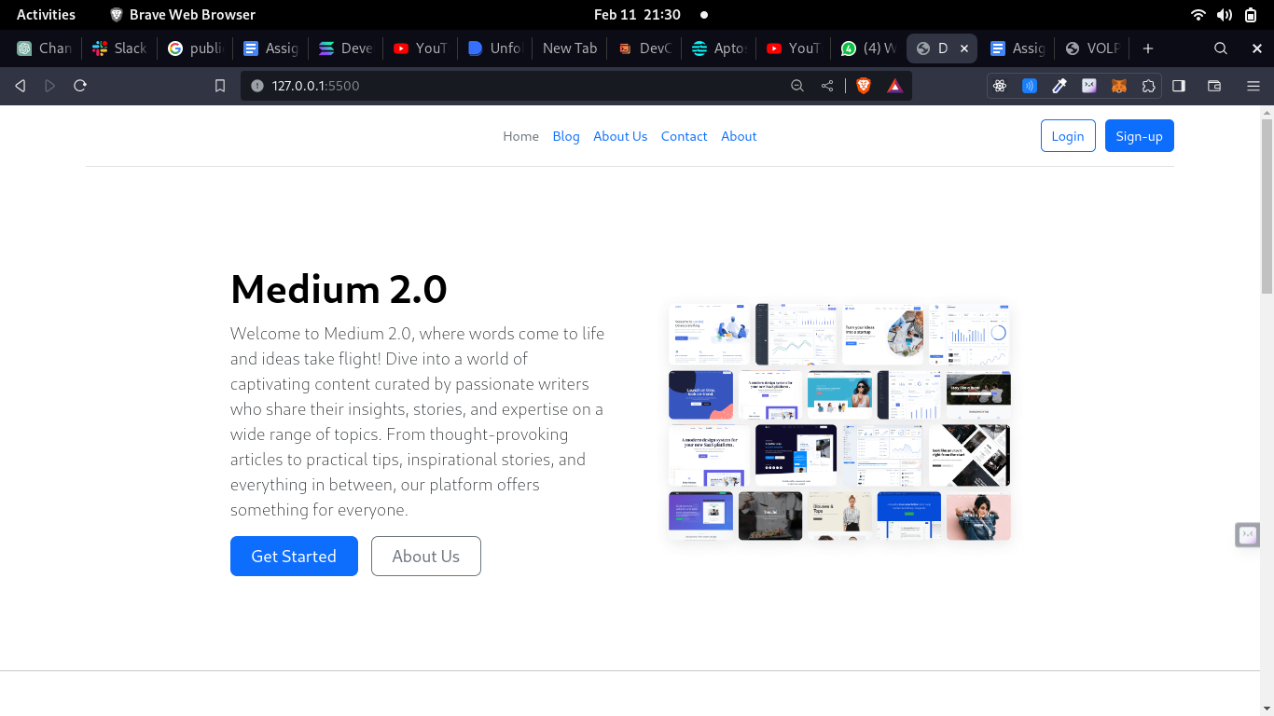

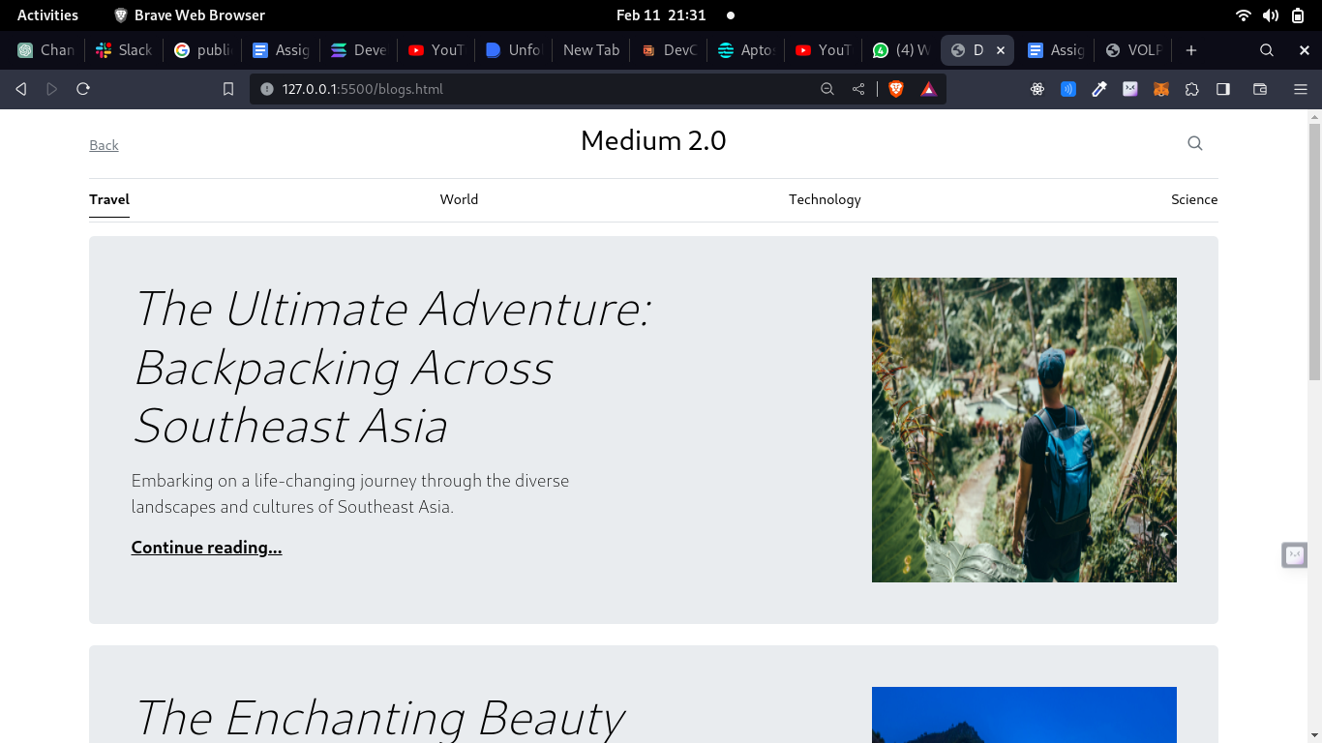

**Blogs of 4 Different Sections ( Travel , World , Technology , Science) (Travel Section)**

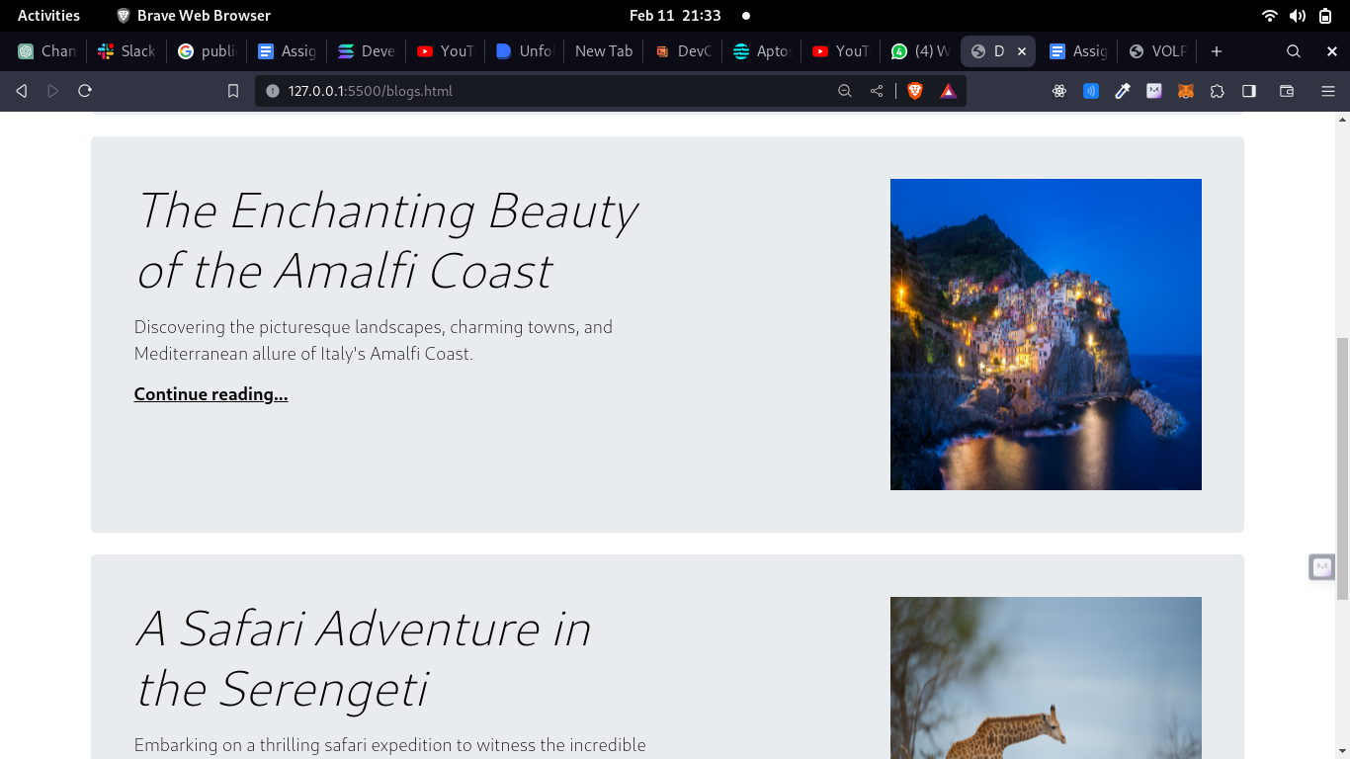

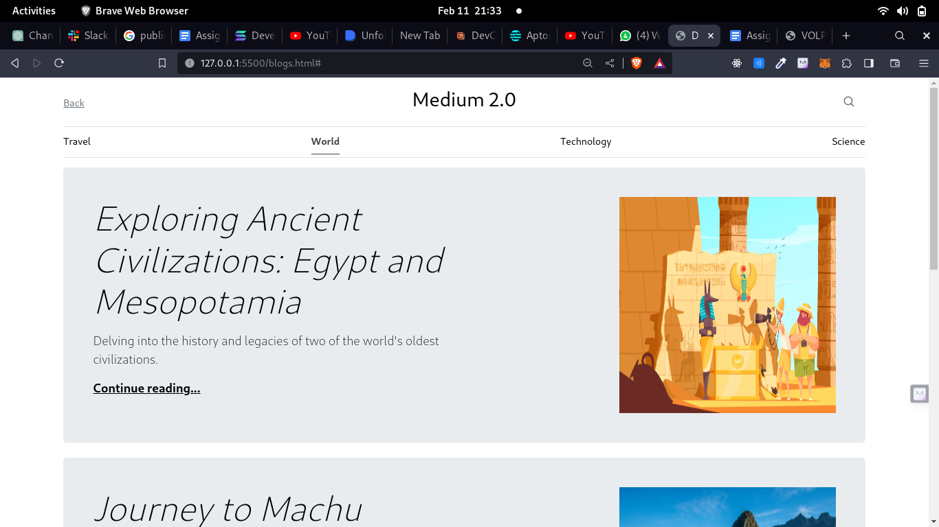

**Blog of World Section**

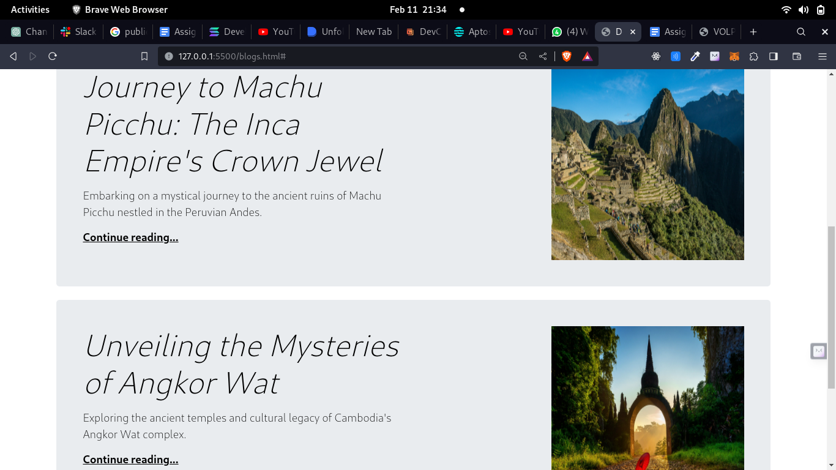

**More Blogs From World Section**

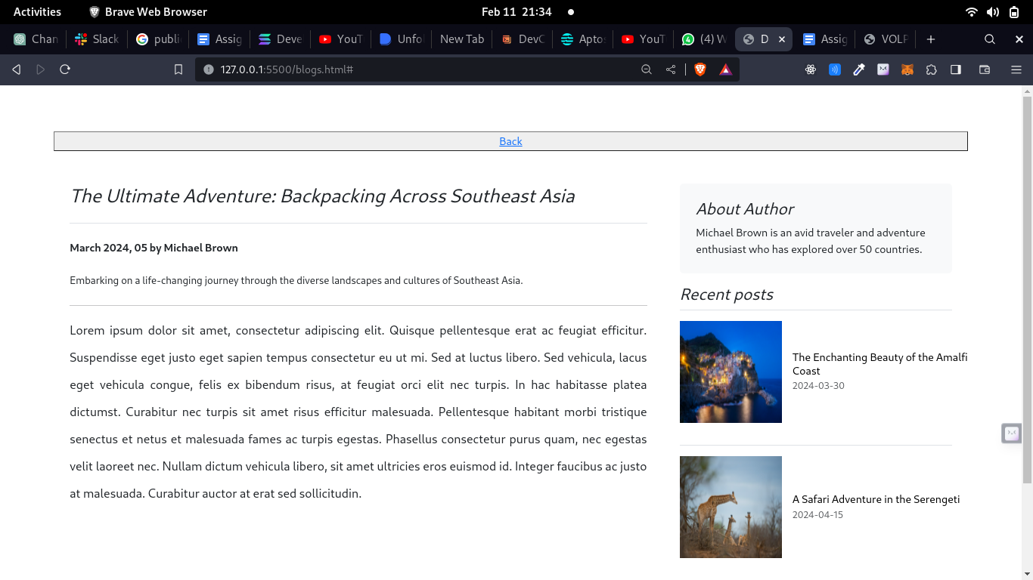

**On Clicking Continue reading button it will redirect to full blog which have details about about author and some more read blogs**